Assignment 3:
• Instance 1 (JM) → Jenkins + Maven → builds WAR
• Instance 2 (APP) → Java + Tomcat → Host website
Create 2 instance :
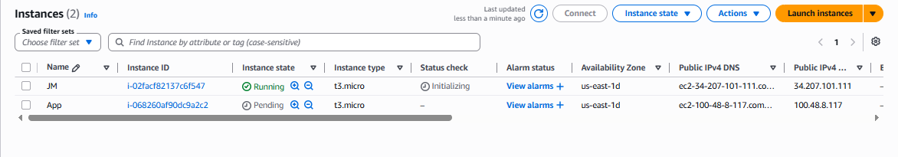

on JM machine need to launch : Jenkins maven git java
on App need to launch : Java and Tomcat
Install java in both machine
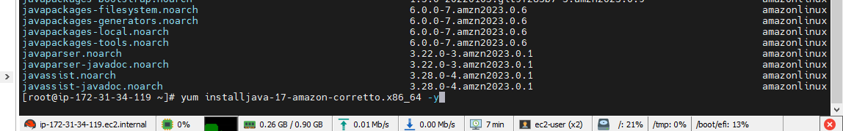
JM :
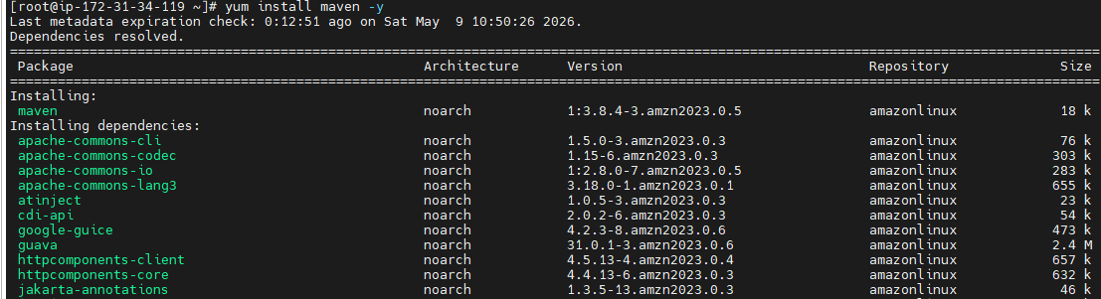
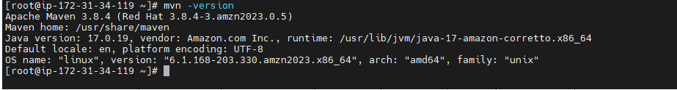

Install GIT :
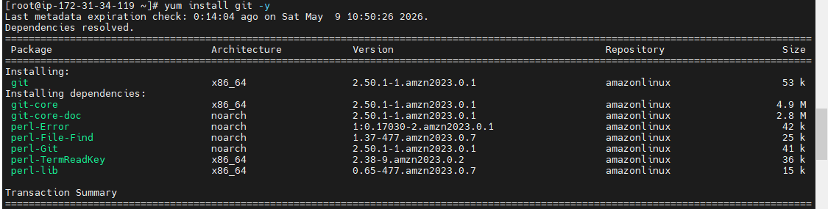
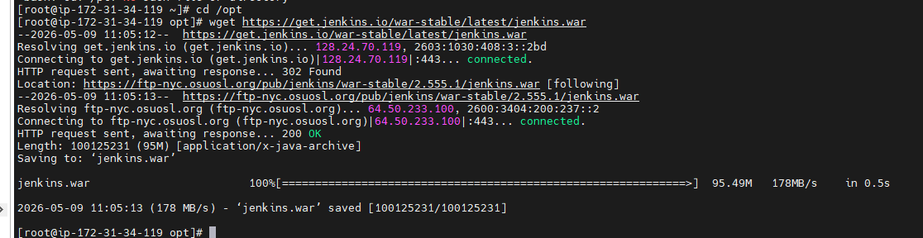

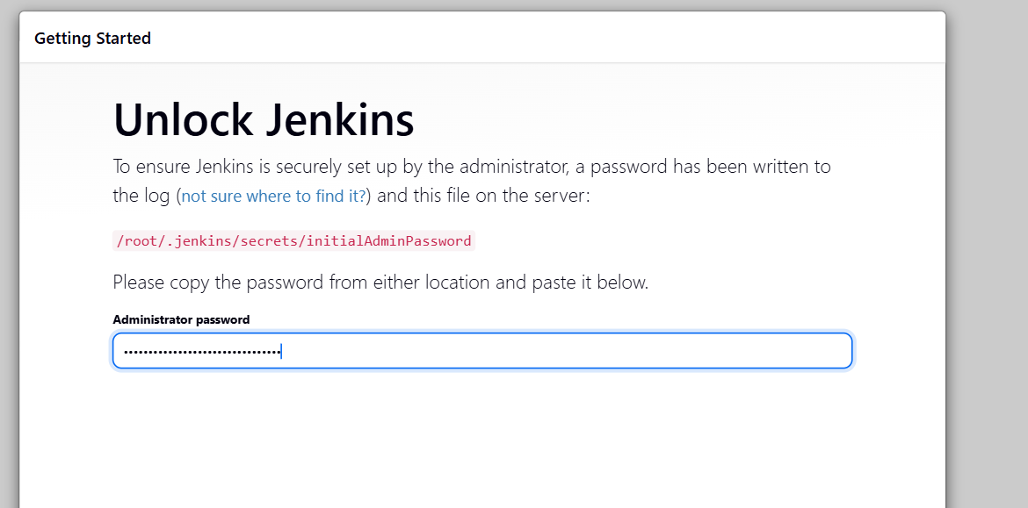

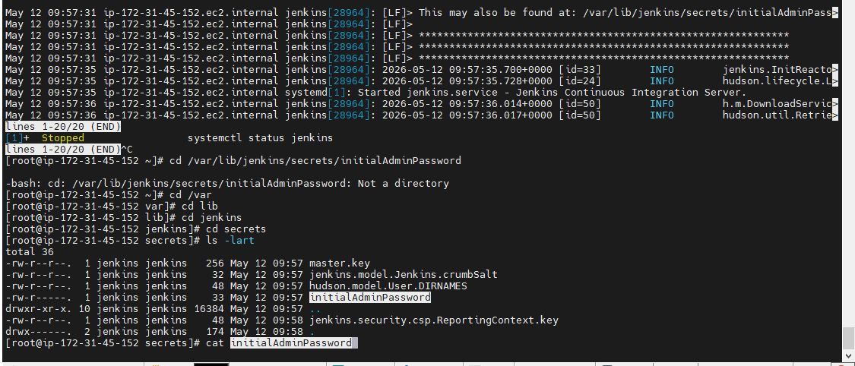

App Server :
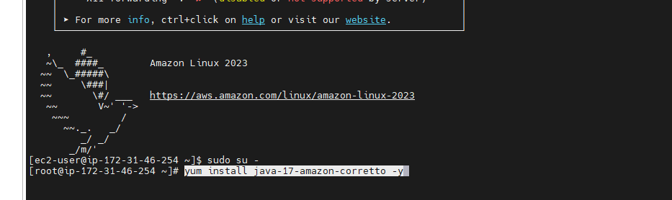

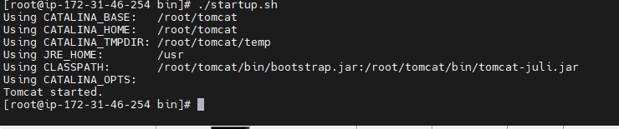

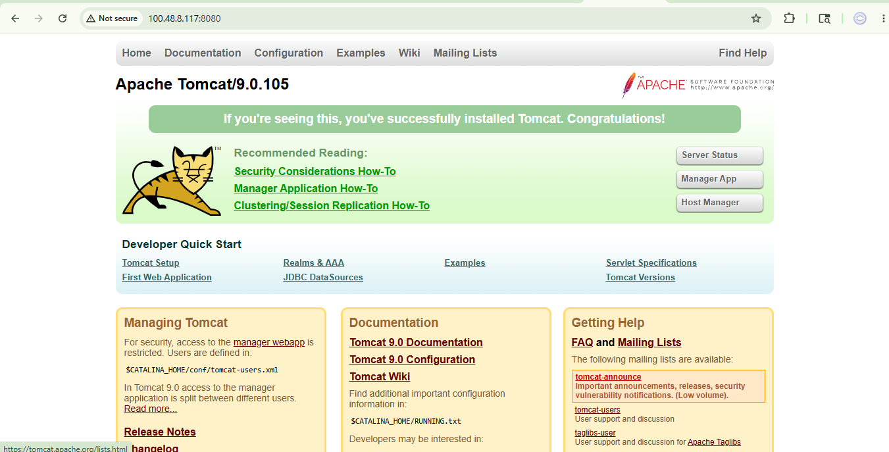

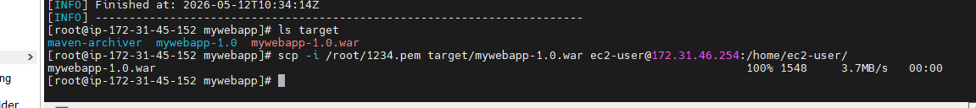

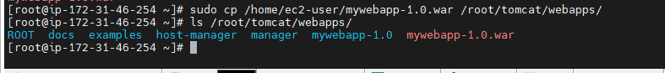
Access it

